Building a Simple Supply Chain model in AnyLogic 6

The problem formulation
This problem formulation is © Copyright by Averill M. Law and is a generalization of the inventory problem in Section 1.5 of his book Simulation Modeling.
A supply chain, which operates 24 hours a day, consists of four components (see the figure below): customers, retailer, wholesaler, and factory. Customers arrive to the retailer with exponential interarrival times having a mean of 0.1 day and demand a single product. The demand size is a discrete random variable that takes on the values 1, 2, 3, 4, and 5 with respective probabilities 0.2, 0.4, 0.2, 0.1, and 0.1.

Retailer
When a demand from a customer occurs, it is satisfied immediately if the inventory level at the retailer is at least as large as the demand. The new inventory level is equal to the old inventory level minus the demand size, resulting in a non-negative inventory level. If T is the time required for a customer to receive their entire order, then 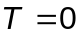.
If the demand exceeds the inventory level, the customer takes the currently available items and the excess of demand over supply is backlogged and satisfied by a future delivery from the wholesaler. The new inventory level is equal to the old inventory level minus the demand size, resulting in a negative inventory level. In this case, T is the time from when the customer first arrives until that time future when the customer receives the remainder of their order.
At the beginning of each day, the retailer reviews its inventory level and decides how many items to order from the wholesaler. If the retailer orders 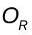 items, it incurs an ordering cost of 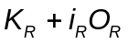, where 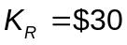 is the setup cost and 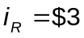 is the incremental cost. Note that includes the cost of shipping by the wholesaler. (If 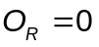, no ordering cost is incurred.) The order is sent to the wholesaler electronically and arrives immediately.
The retailer uses a stationary 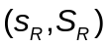 policy to decide how much to order, i.e.,
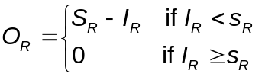

Customers

Retailer

Wholesaler

Factory
Order
Order
Demand

Shipment
Shipment
Supply

where 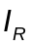 is the inventory level at the beginning of the day. (The ordering decision is not based on any anticipated shipments from the wholesaler.)
When a shipment arrives from the wholesaler (see the discussion of the wholesaler below), it is assumed for simplicity that it is used immediately to satisfy any backlogged customers. Furthermore, it is assumed that a backlogged customer, if necessary, is willing to take part of their outstanding items at the time that the order arrives. (Assume that there is no travel time for a customer to get to the retailer, since they live nearby.) In order to compute T for a backlogged customer, it is necessary for the customer to have two attributes while waiting in a backlog queue: original demand time and the current number of items backlogged.
Let 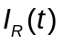 be the inventory level at the retailer at time t, which could be positive, negative, or zero. Let 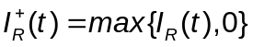 be the number of items physically on hand in the inventory at time t, which will be non-negative. Let 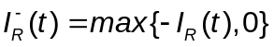 be the backlog at time t, which will also be non-negative.
Let 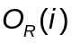 be the ordering cost incurred in the ith day {i.e., the time interval 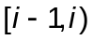} by the retailer for 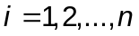, where n days is the simulation run length. Then the average ordering cost per day is
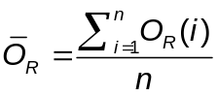
We assume that the company incurs a holding cost of 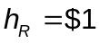 per item per day held in (positive) inventory. For the n-day period, the time-average (per day) number of items held in inventory is
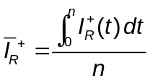
Thus, the average holding cost per day is 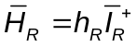.
We assume that the company incurs a shortage cost of 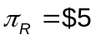 per item per day in backlog. For the n-day period, the time-average (per day) number of items in backlog is
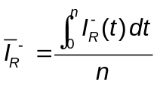
Thus, the average shortage (or backlog) cost per day is 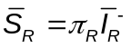.
Finally, the average total cost per day for the retailer of maintaining its inventory, 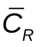, is
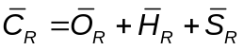
Assume that the initial inventory level for the retailer is 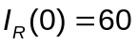 and that no order to the wholesaler is outstanding. The retailer actually evaluates its inventory level at times 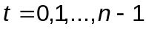, since the simulation is over at 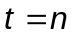.

Wholesaler
At the beginning of each day, the wholesaler first checks to see if there are any orders from the retailer that need to be shipped, including one that might have just arrived. If so, it will ship in a FIFO manner any full orders for which it has enough inventory. (Partial orders are not shipped.) However, there is a random lead (or shipping) time, 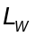, for the shipment to actually arrive at the retailer, where is uniformly distributed on the interval [0.25, 0.5] day. The new inventory level at the wholesaler, 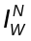, is the old inventory level minus the number of items shipped. Any order that is not shipped is backlogged.
After any orders are shipped to the retailer, the wholesaler reviews its current inventory level, , and decides how many items to order from the factory. If the wholesaler orders 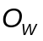 items, it incurs an ordering cost of 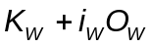, where 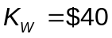 is the setup cost and 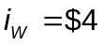 is the incremental cost. Note that includes the cost of shipping by the factory. (If 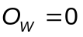, no ordering cost is incurred.) The order is sent to the factory electronically and arrives immediately.
The wholesaler uses a stationary 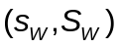 policy to decide how much to order, i.e.,
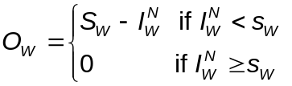
When a shipment arrives from the factory (see the discussion of the factory below), the items in the shipment are added to the wholesaler’s inventory. However, there are no items sent to the retailer at this time, since shipments are only made at the beginning of a day.
The average cost per day for the wholesaler of maintaining its inventory, 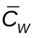, is
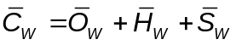
where we assume that 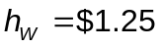 and 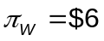. (The calculation of is analogous to the calculation of .)
Assume that the initial inventory level for the wholesaler is 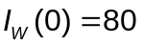 and that no order to the factory is outstanding. The wholesaler actually evaluates its inventory level at times 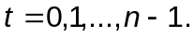

Factory
At the beginning of each day, the factory first checks to see if there are any orders from the wholesaler that need to be shipped, including one that might have just arrived. If so, it will ship in a FIFO manner any full orders for which it has enough inventory. (Partial orders are not shipped.) However, there is a random lead (or shipping) time, 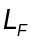, for the shipment to actually arrive at the wholesaler, where 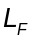 is uniformly distributed on the interval [0.5, 1] day. (The probability of being exactly 1 day is 0 by the definition of a continuous random variable.) The new inventory level at the factory, , is the old inventory level minus the number of items shipped. Any order that is not shipped is backlogged.
After any orders are shipped to the wholesaler, the factory reviews its current inventory level, , and decides how many items to manufacture. (Assume that raw materials are always available.) If the factory manufactures 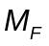 items, it incurs a manufacturing cost of 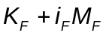, where 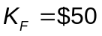 is the setup cost and 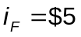 is the incremental cost. Furthermore, the time required to manufacture items is 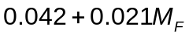 days. The value 0.042 day (or 1 hour) is the time to setup the manufacturing line and 0.021 day (or 0.5 hour) is the time to manufacture each item. (If 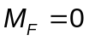, no manufacturing cost is incurred.)
When a batch of items has been completed by the factory, the items are added to the factory’s inventory. However, there are no items sent to the wholesaler at this time, since shipments are only made at the beginning of a day.
The factory uses a stationary 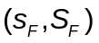 policy to decide how much to manufacture, i.e.,
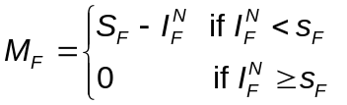
The average cost per day for the factory of maintaining its inventory and manufacturing the required items, 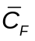, is
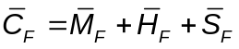
where 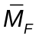is the average manufacturing cost per day, and we assume that 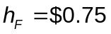 and 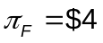. Assume that the initial inventory level for the factory is 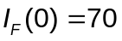 and that no items are in the process of being manufactured. The factory actually evaluates its inventory level at times

Output Statistics and Plots for the Simulation
Run the simulation for n = 365 days and dynamically display the following on the screen:
- The average total cost per day for the retailer, the wholesaler, the factory, and the sum of the three costs (update these statistics once a day)
- The average time for a customer to get their entire order, 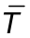
- Plots of , 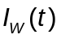, and 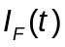 on the same graph
- A histogram of the individual T values.

The model architecture
As long as AnyLogic is an OO tool, it is obvious and natural to create an ActiveObject class for each SC element type: Retailer, Wholesaler and Factory. We will build those objects as autonomous units able to make decisions and having clearly defined interfaces with their partners.
Although the problem formulation is done for a fixed (and simplest possible) SC configuration with a single Retailer, Wholesaler and Factory, we will design those objects capable of working in arbitrary SC networks because it costs almost zero development efforts.
We will assume that SC will be configured graphically in AnyLogic editor by instantiating elements and connecting them. Therefore we will use AnyLogic ports as SC element interface points: ports can be easily connected using mouse. [There are alternatives to ports, e.g. one could parameterize the objects with their partner objects and use method calls. That would make sense if we were configuring a SC from, say, a database, but for our simple case study we will use manual graphical connections.]
Retailer and Wholesaler will have two ports each: one for receiving orders and sending products and another – for sending orders and receiving shipments, and Factory will have one port because we assume the raw material is always available at the factory and do not model the SC further.
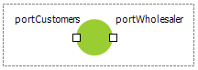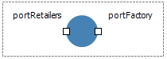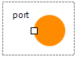
The top-level model structure will look like this:
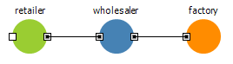
But it will be possible to create more complicated configurations using the same set of objects, like shown below:
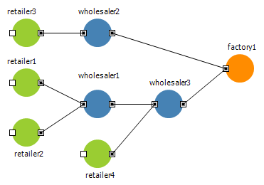
In the first version of this SC we will not create specific ActiveObjects representing customers: in the original problem formulation customers do not have any significant behavior and are needed just to generate demands and collect statistics on demand satisfaction. This can be done by simple event generation at the top level of the SC. [Later on if we decide to extend the problem definition with e.g. product discards or limited waiting time, etc. we can model individual customers using agents.]

Information and material flow. Object interfaces
In any SC there are two flows going in opposite directions: information flow (demand and orders) from the end customers to retailers to wholesalers and further up to the factory, and material flow from the factory down to the end customers via wholesalers and retailers.
In our model we need to represent the units of those flows. Those units are essentially passive data units and the simplest construct to model them would be object with data fields. As the data definition language in AnyLogic is Java we will create three Java classes:
- Demand – the demand of a single customer; contains the number of requested units. Messages of type Demand will be received at the portCustomers of Retailer object.
- Order – the order to a Wholesaler or a Factory; contains the amount being ordered and also the shipping address, which is needed to identify the partner in case of non-primitive SC networks. We will use the Port of the ordering object as the shipping address. Messages of type Order will be sent via portWholesaler of Retailer object and portFactory of Wholesaler object and received at the portRetailers of Wholesaler object and at port of the Factory object.
- Shipment – the shipment to the Retailer or Wholesaler; contains the amount being shipped. Messages of type Shipment will be sent via portRetailers of Wholesaler object and port of Factory object and received at portWholesaler of Retailer object and at portFactory of Wholesaler object.
AnyLogic Java class wizard will generate the following code:
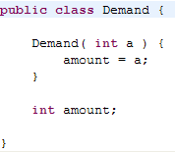
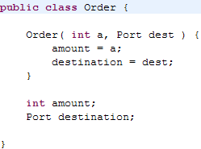
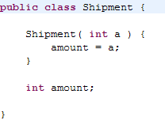
We also need to specify at each SC element port the type of messages it will be sending and receiving: this works as additional correctness check and also simplifies the message processing.
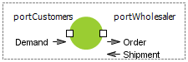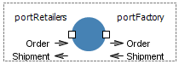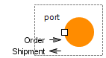
Please note that we are designing the model in such a way that there will be no communication between SC elements other than message exchange, so the elements will not need to know anything about each other’s internal structure. This enables independent development of Retailer, Wholesaler and Factory implementations, and also enables connecting Wholesaler to another Wholesaler, Retailer directly to a Factory, etc.

Model of Wholesaler
We will start implementing the Wholesaler with defining its internal information (state) and parameters. Clearly, we need to remember the inventory level, and the order backlog. As the products in our SC are identical, the inventory level can be simply modeled as plain integer variable. And as long as the orders are processed in a FIFO manner, we can keep them in a collection such as LinkedList. Both plain variables and collections are defined graphically in AnyLogic:
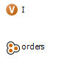
Here I is the inventory level with a certain initial value and orders is a collection of type LinkedList holding elements of type Order (Order was described in the previous section), initially empty. Note that inventory level in all SC components will represent the number of items physically available at the component.
The parameters of Wholesaler are defined straightforwardly from the problem formulation:
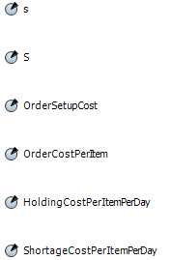
Here s and S are the inventory policy parameters.
The next step is to determine what events or conditions cause this object to act, are its triggers. We can identify three such triggers for the Wholesaler:
- An Order is received (from a Retailer or another Wholesaler – we do not care now)
- A Shipment arrives (from a Factory of another Wholesaler)
- At the beginning of each day: the incoming Orders are processed, products are shipped and outgoing order (to a Factory or another Wholesaler) is issued.
As the reaction to those events does not alter (does not depend essentially on the internal state of the Wholesaler) and the order of them is not strictly defined, it does not make sense to use a statechart in the model of the Wholesaler. Instead, we will define reactions to orders and shipments directly at the ports where the corresponding messages arrive, and put the “beginning of day” action in a method – see the discussion of synchronization of the SC elements below. [This is important part of the model development process: you should always carefully analyze the behavior of the real-world object and determine what AnyLogic modeling language construct fits best: statechart, event, SD equations, process flowchart, etc.]
Let us define the actions. The simplest one is the reaction on the shipment arrival: we simply add the received amount to the inventory. The place to insert that action is the On Receive field of the portFactory:
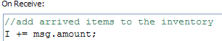
The reaction on the order arrival is also obvious: we should add the order to the end of the queue. This is written in the On Receive field of the portRetailers:
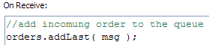
In the above fragments “msg” is used to access the just arrived message. [You can find out what pre-defined names you can use by pointing the mouse at the light bulb appearing to the left of the field editor while you type.]
The third (and the last) action is order processing (including shipping out the products) possibly followed by issuing the order to the factory. Before we define that action, let us think of how should we model shipment delivery. According to the problem definition, there is a (randomly distributed) shipping time between the time the Wholesaler sends the shipment and the time the retailer (or another wholesaler) receives it. Once the shipment is sent, it logically leaves the Wholesaler and does not affect its future activity. The best AnyLogic construct to use in this case is Dynamic Event. One can associate arbitrary information with a dynamic event as well as the action that should be executed when the event occurs. In our case the information is the Shipment itself (carrying inside the amount being shipped) and the destination port. This is how we will define the dynamic event Delivery:
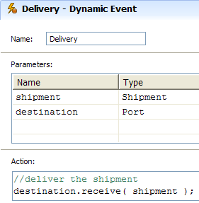
Note that we are invoking the method receive( <message> ) of a (remote!) port. This method immediately and directly delivers the message to the port.
Having defined that, we can write the order processing algorithm. We will do it in a method (function) of the Wholesaler object called checkOrders:
This is the body of the function:
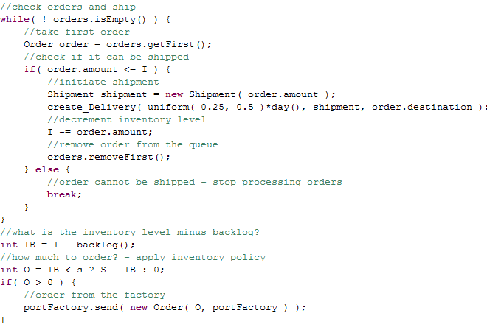
In the order processing part we call the method create_Delivery( <lead time>, <parameters…> ) that has been auto-generated by AnyLogic after we have defined the dynamic event Delivery. The day() functions returns the duration of a day in model time units.
In the bottom part of that code we analyze the inventory level, the order backlog and apply inventory policy. To calculate the total amount of the backlogged orders we use the method backlog() defined in the following way:
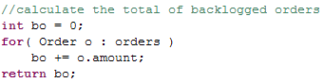
The method send( <message> ) of a port will send the message to the port of another object along the existing connections. The call of new Order( <amount>, portFactory ) creates a new Order and parameterizes it with the amount being ordered and the delivery address – in our model the portFactory of this Wholesaler.
This is it with the Wholesaler. You may have noticed that we have used only low-level AnyLogic primitives while implementing the Wholesaler behavior: ports, events, variables and functions, and have not used any higher-level constructs such as process block diagrams. In particular, the order processing is done using Java code. Alternatively we could use Queue, Delay and other higher level constructs from AnyLogic Enterprise Library, which would save us some code writing. We however have done that deliberately: in more or less realistic supply chains the information handling is not primitive and trying to define it by connecting blocks may lead to badly structured, unreadable and unmanageable models (not to speak about the simulation performance). Our viewpoint is that pure information processing should be done using languages specifically designed for that (in this case it is Java), and process flowcharts should only be applied when you need to model processes with time delays, resource sharing, etc.

Model of Factory
The model of the Factory will be pretty much similar to the model of the Wholesaler. The state of the factory is also defined by the inventory level and the order backlog. The only difference is that instead of receiving external shipments that add to the inventory, the Factory receives the batches of products from itself. The triggers of the Factory are:
- An Order is received (from a Wholesaler or a Retailer)
- The manufacturing of a batch of products is finished
- At the beginning of each day: the incoming Orders are processed, products are shipped and manufacturing is setup if needed.
The manufacturing process is modeled using dynamic event Manufacturing:
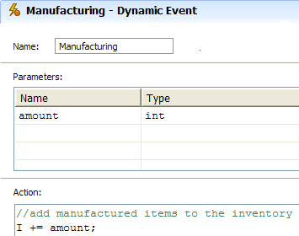
And the checkOrders method is implemented this way:
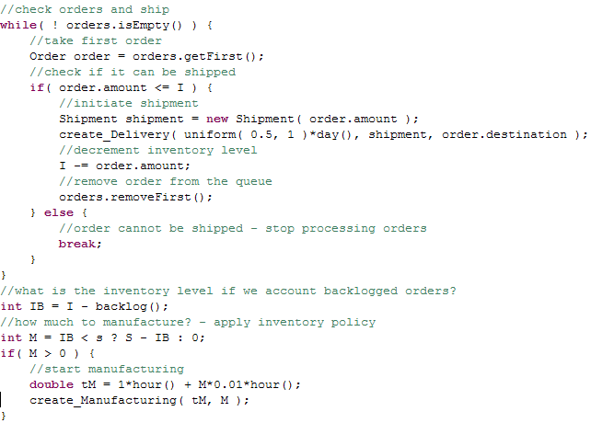
The function hour() returns the duration of an hour in model time units, and the method create_Manufacturing( <time delay>, <parameters…> ) schedules a Manufacturing event described above. [We have changed the time needed to manufacture one item to 0.01 hour as the original value in the problem definition was causing the factory to initiate manufacturing processes taking longer than one day, which does not make sense in this SC.]
Please also note that we have defined the cost-related parameters of the objects (such as OrderSetupCost in the Wholesaler or ManufacturingCostPerItem in the Factory), but have not used them so far. Our plan is to get the running model as soon as possible and add cost analysis and statistics collection later on.

Model of Retailer
As one can expect, the Retailer is again similar to Wholesaler: it also orders products, receives shipments and supplies the demands. The difference however is in the manner the retailer sells the product to the end customers: this is done immediately when a demand occurs if the product is on the stock, or (for backlogged demands) immediately upon arrival of a shipment from a Wholesaler (or a Factory).
The action taken on a new demand and on the arrival of a shipment is the same: the Retailer needs to supply what is possible. That action is defined in the method checkDemands:
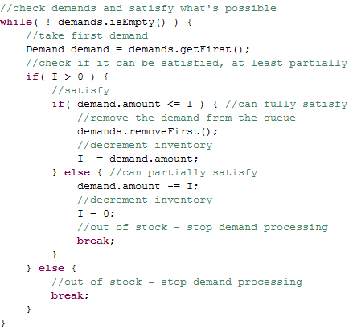
Note that supplying a demand is modeled just by deleting the corresponding Demand object from the demands queue. Later on we will add waiting time statistics collection here.
The method checkDemands() is called in On Receive fields of portCustomers:
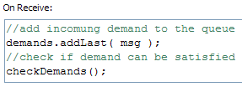
and portWholesaler:
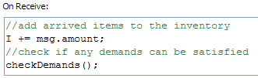
As you can guess, the internal state of Retailer is implemented by the queue of objects of type Demand (LinkedList demands) and the inventory level I – an integer variable.
At the beginning of each day the Retailer decides how much to order. This is modeled by the method orderFromWholesaler:
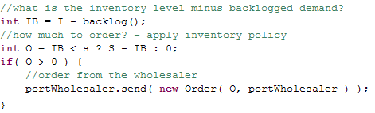

Model of Demand
The first thing we need to model the end customers’ demand is the distribution of demand size. According to the problem definition, the demand size takes several integer values with predefined probabilities. For creating such distributions AnyLogic supports CustomDistribution construct that can take a TableFunction as parameter. Therefore we first define a table function demandSizeProbability that maps the demand size to its probability:
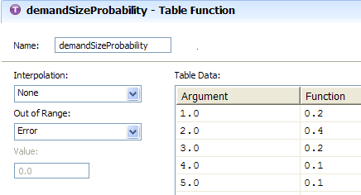
[By setting the Interpolation to None we tell the table function that it only has discrete set of arguments]. And then we define a CustomDistribution object providing that table as a parameter:
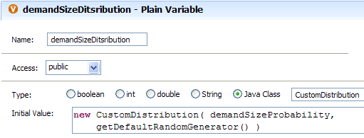
Now the call to demandSizeDistribution.get() will return a random integer from 1 to 5 with the corresponding probability.
The rest is simple: as the demand occurs at the rate of 10 per day, we can use AnyLogic Rate Event (rate event occurs with exponentially distributed inter-occurrence time) and insert a new Demand message into the Retailer’s portCustomers on each occurrence:
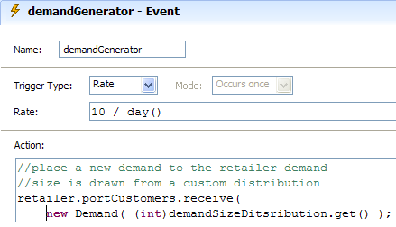
The prefix “(int)” before the draw from the distribution converts a real value to the integer value and is needed because CustomDistribution class returns real values (of Java type double), and no implicit conversion from double to int is made.
These three items modeling the demand (the table function, the distribution, and the event demandGenerator) are placed on the top-level object Main (described in the next section), and retailer refers to an instance of Retailer object located on the same level.

Putting the SC components together. Model synchronization
We have developed three ActiveObject classes: Wholesaler, Factory and Retailer, and we know how to model the demand. Now we can setup a specific SC configuration and run the model. We will need one more ActiveObject class Main that will serve as a top-level object where the whole SC will be assembled. We can drop (embed) as many instances of SC component classes as we need and connect them on the diagram of Main. The simplest SC as described in the original problem formulation will look like this:
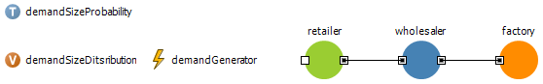
One important thing however is missing: we have not defined when and in what order the SC elements will execute their shipping/ordering policies: so far we have only defined the corresponding methods in the three objects (orderFromWholesaler in Retailer, and checkOrders methods in Wholesaler and Factory), but these methods are not called anywhere.
Several approaches can be taken here. To keep the SC elements as independent as possible we can make them completely asynchronous and let each object control the moments of time when the policy methods are invoked. Then to ensure e.g. the wholesaler always sees the “just arrived” orders from a retailer, we could set the Wholesaler to:
- Call its checkOrders method always later than orderFromWholesaler method is called at Retailer, say 15 minutes later
- Call its checkOrders method upon reception of an order from the Retailer (or from all connected retailers in case of more complex SC network).
Both methods make sense (and may be close to what is happening in real supply chains), but in our simple case we will use a different approach: we will impose global synchronization of the SC from the upper level Main object: it is technically very easy and also conforms with the problem formulation requiring that policy executions are done at the same time yet in particular order. Therefore we will create a Cyclic Timeout Event at the Main object that will be executed at the beginning of each day and invoke the shipping/ordering policies of the SC elements:
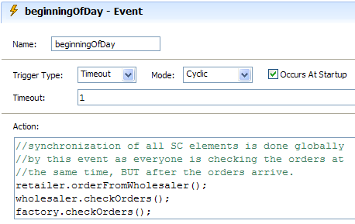
The supply chain model is now completed and ready to run.

Defining simulation experiment
Before running the model let us define the simulation experiment duration and time units. We want the model time units to be days, and the run duration to be one year. That is defined in the Model Time property page of the experiment:
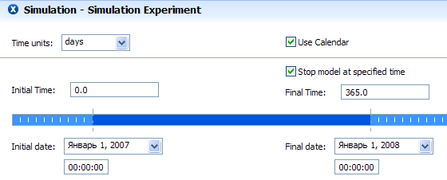

Visualizing SC dynamics
While running the developed model you can see that SC is really working (for example, the inventory levels go up and down), but we need to define some business graphics elements to have a better picture of what is going on. The most important graph that we wish to see is the dynamics of inventory levels at the Retailer, Wholesaler and the Factory. In the Main object we will define three datasets: dsIRetailer, dsIWholesaler, and dsIfactory. They are defined like this:
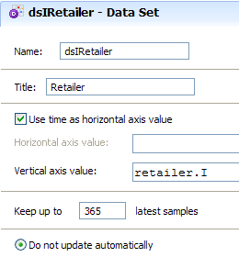
The dataset above will keep 365 samples and, when update, will add a pair < current model time, the value of I at retailer object >. The other two datasets are defined analogously. Finally, we need to drop a Time Plot and add those three datasets to it. We will setup the plot will update the datasets at the end of each day:
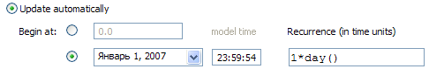
This is a typical dynamics of the SC with default parameter values:
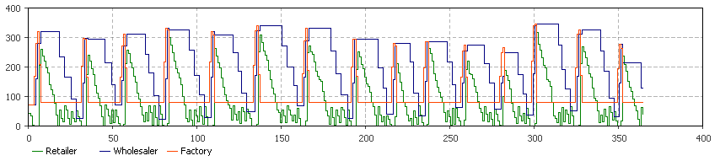

Adding cost analysis and customer satisfaction statistics
What is first noticed in this graph is the excessive amount of inventory at the wholesaler. While the guess is that it is most probably caused by ordering policy that is far from optimal, we can introduce a quantitative measure of SC performance as suggested in the problem definition. We will show how this is done using Wholesaler object as an example.
Fisrt, remember that we have already defined four cost-related parameters in the Wholesaler object: OrderSetupCost, OrderCostPerItem, HoldingCostPerItem, and ShortageCostPerItem.
Now we will define three Statistics objects. The statistics orderingCost will accept discrete samples of cost associated with each order made by the Wholesaler, therefore it is of discrete type:
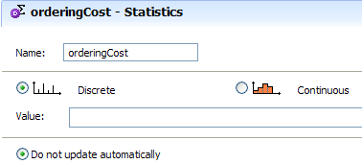
The statistics holdingCost is, on the contrary, continuous: it calculates the integral of continuously changing value, namely cost associated with having items on the stock at Wholesaler:
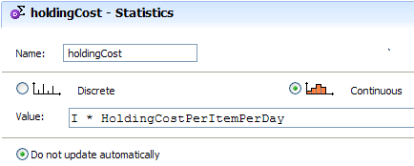
The values that will be added to that statistics are the inventory levels multiplied by the cost per item per time day. The shortageCost is defined in exactly the same way, but there we will use backlog() * ShortageCostPerItemPerDay as the value.
The statistics objects need to be updated when the corresponding changes occur in the model. We will insert those updates in a few places of the Wholesaler. First place is the checkOrders method where we will add the fragments highlighted below:
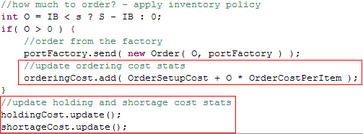
The shortageCost must be updated when an order arrives, so we add code to On Receive field of the portRetailers:
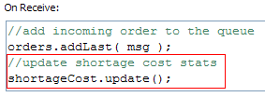
Finally, the holdingCost must be updated when a shipment arrives to the Wholesaler, so we write in the On Receive field of portFactory:
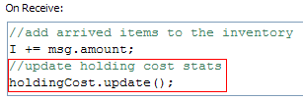
That’s it with cost analysis of the Wholesaler. Please note that we are updating the shortage and holding cost not once a day, but exactly at the events of inventory of backlog changes unlike suggested in the problem formulation.
The cost analysis at the Retailer and the Factory is done in the same way.
To visualize the cost we add three Stack Charts to the diagram of Main, each displaying the cost structure associated with one SC component. The stack chart for the Wholesaler, for example, will display these three data items:
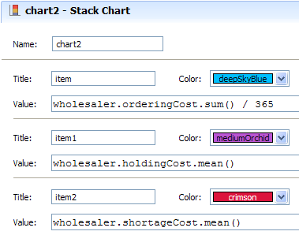
Please note that for continuous statistics we can take mean value, which is the cost per time unit (day), while for the discrete statistics on orders we cannot take mean because there are days when no orders are made; therefore we need to divide the its sum by the number of days simulated (365). Under the default parameter settings we will observe the following picture (the bars correspond to costs at Retailer, Wholesaler and Factory):
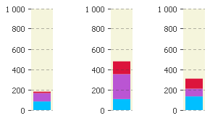
Our goal is to minimize the SC running cost yet keeping the customers satisfied. Therefore before starting any parameter variation or optimization experiments we need another quantitative measure – this time for customer satisfaction. As such, we can take customer waiting time distribution as suggested in the problem definition. To measure the waiting time we must remember the time the demand occurred (its timestamp) and then, when the demand is fully supplied, add the difference between the supply time and the demand timestamp to a histogram.
To do that, we will add a timestamp field to the Demand data class (remember that time in AnyLogic is represented by Java type double):
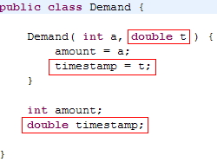
That field will be set when the demand is generated, i.e. in the demandGenerator event:
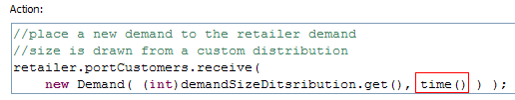
And in the checkDemands method of the Retailer we will use that timestamp to update the customer waiting time histogram:
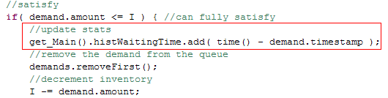
The histogram itself is defined in the Main class (therefore the Retailer object refers to it via Main – see the prefix get_Main()), as well as the chart displaying that histogram.
Now a run with the default parameters will give us the following results:
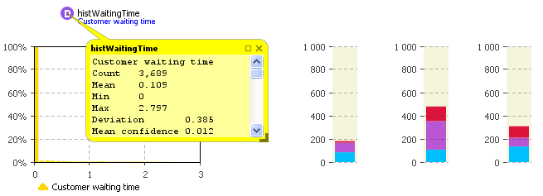
You can see that the greater majority of the customers do not wait for the product. The model is now completely setup to search for optimal SC management.

